**JUNIT TESTING**

**Exercise 1: Setting Up JUnit**

**Junit.java :**

package junit;

public class Junit1 {

    public static int add(int a,int b) {

        return a+b;

    }

}

**Test1.java :**

package junit;

import static org.junit.jupiter.api.Assertions.*;

import org.junit.jupiter.api.Test;

class test1 {

*@Test*

void test() {

Junit1 m=new Junit1();

*assertEquals*(5,m.*add*(2, 3));

}

}

**Output :**

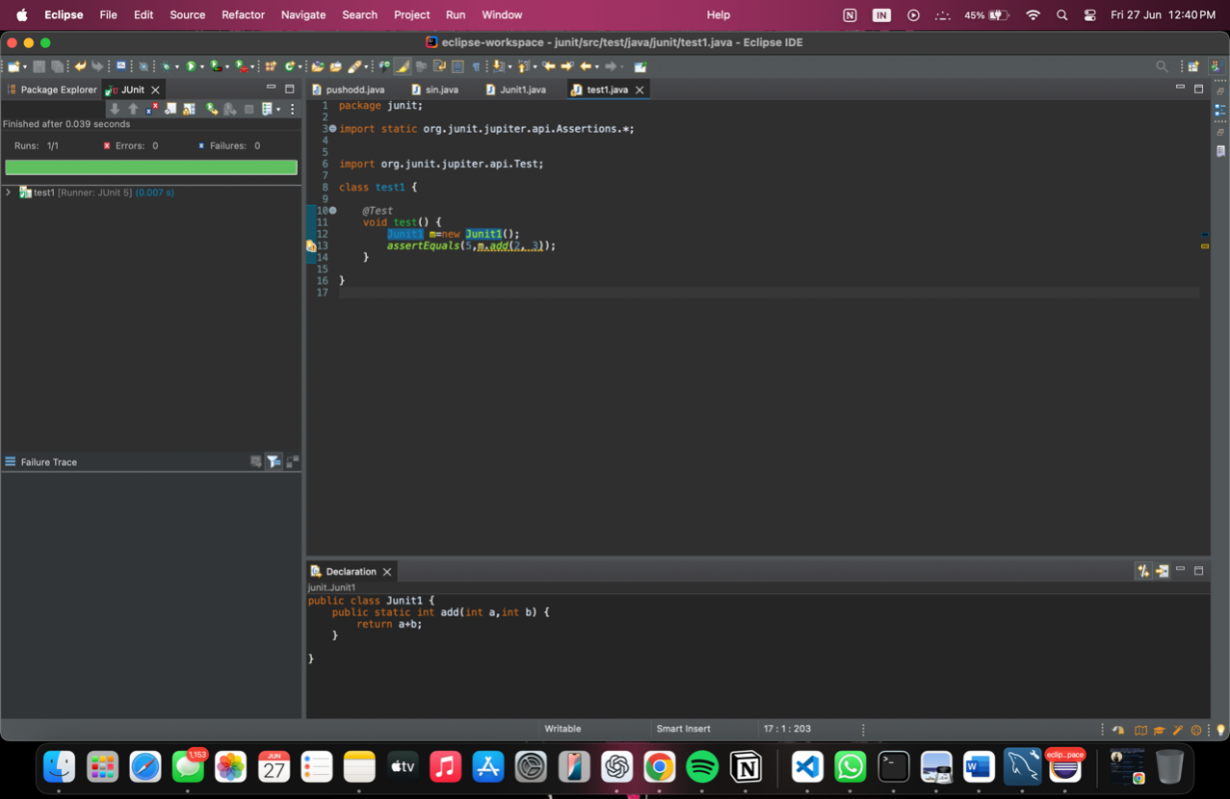

**Exercise 3: Assertions in Junit :**

**Test2.java :**

package junit2;

import static org.junit.jupiter.api.Assertions.*;

import org.junit.jupiter.api.Test;

class test2 {

@Test

void test() {

assertEquals(5, 2 + 3, "2 + 3 should equal 5");

assertTrue(5 > 3, "5 should be greater than 3");

assertFalse(5 < 3, "5 should not be less than 3");

String str = null;

assertNull(str, "String should be null");

Object obj = new Object();

assertNotNull(obj, "Object should not be null");

}

}

**Output:**

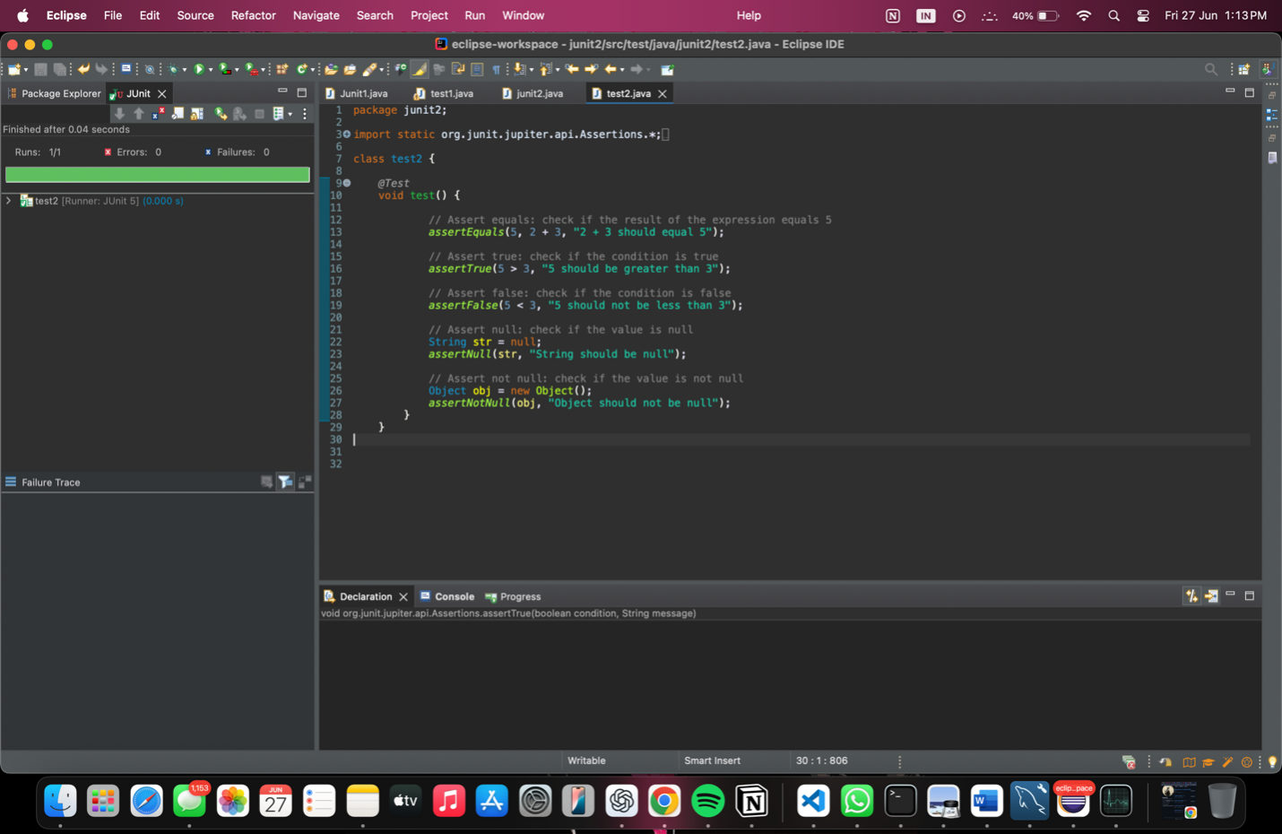

**Exercise 4: Arrange-Act-Assert (AAA) Pattern, Test Fixtures, Setup and**

**Teardown Methods in Junit**

**Junit4.java:**

package Junit4;

public class Junit4 {

public int add(int a, int b) {

return a + b;

}

public int subtract(int a, int b) {

return a - b;

}

}

**Test4.java :**

package Junit4;

import org.junit.jupiter.api.*;

import static org.junit.jupiter.api.Assertions.*;

class test4 {

private Junit4 c;

*@BeforeEach*

public void setUp() {

System.***out***.println("Setting up...");

c = new Junit4();

}

*@AfterEach*

public void tearDown() {

System.***out***.println("Tearing down...");

c = null

}

*@Test*

public void testAddition() {

// Arrange

int a = 5;

int b = 3;

// Act

int result = c.add(a, b);

// Assert

*assertEquals*(8, result, "5 + 3 should equal 8");

}

*@Test*

public void testSubtraction() {

// Arrange

int a = 10;

int b = 4;

// Act

int result = c.subtract(a, b);

// Assert

*assertEquals*(6, result, "10 - 4 should equal 6");

}

}

**Output :**

